OPERATING SYSTEMS AND SYSTEM PROGRAMMING PRACTICAL – Week 3
Name: S Svara Haasini
Roll No: 2520090170

Image 1: Source Code (Part 1)
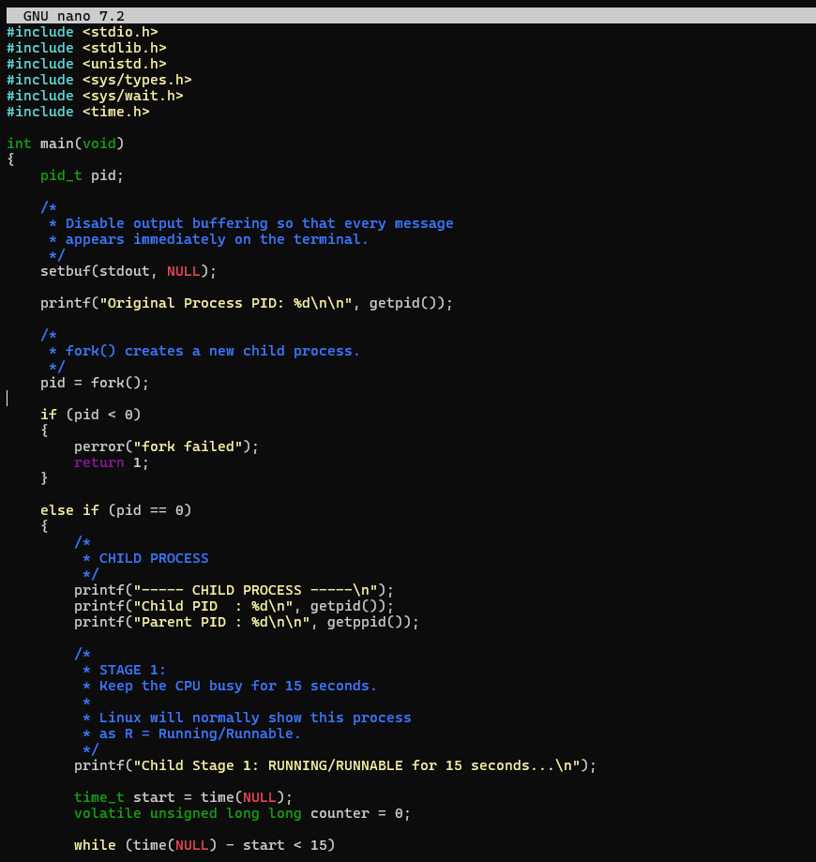

Image 2: Source Code (Part 2)
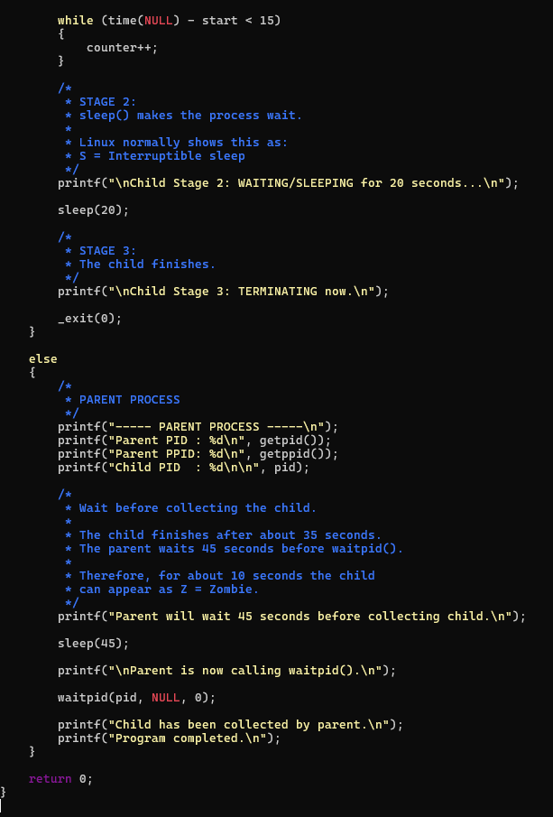

Image 3: Execution Output (Run 1)
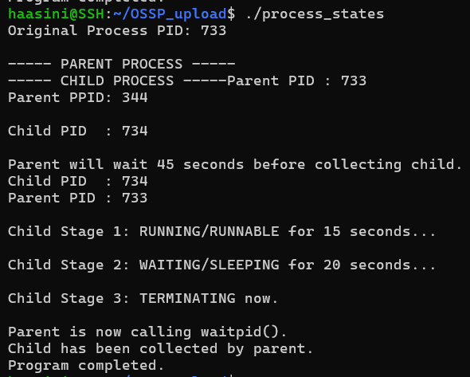

Image 4: Execution Output (Run 2)
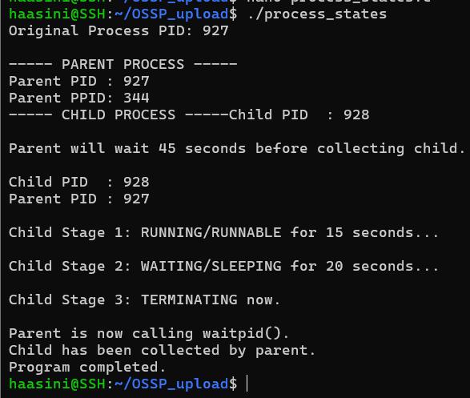

Image 5: Process State Monitoring (ps, grep, top)
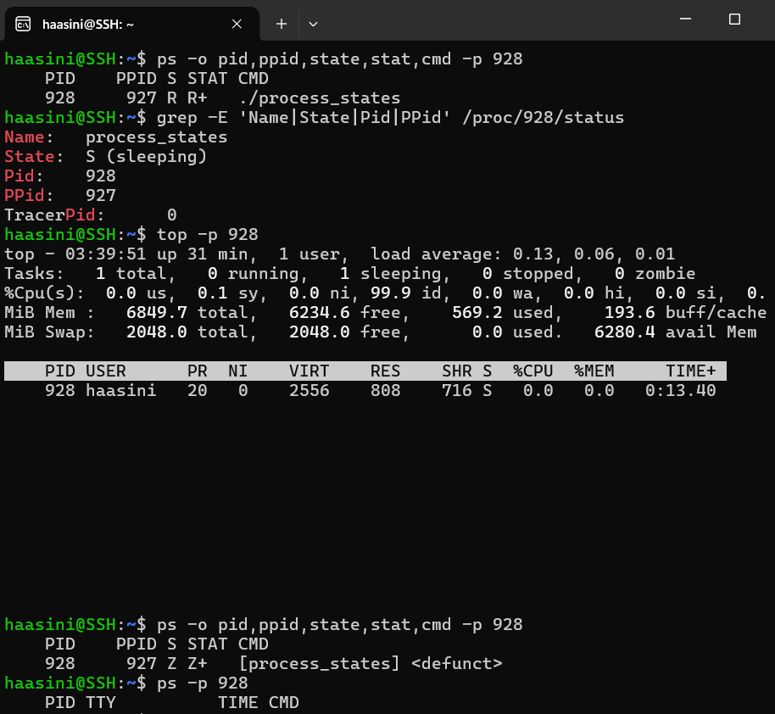

Image 6: Assignment Specification
